[](http://rds.yahoo.com/_ylt=A0WTb_vjCBlM5jsAaTGJzbkF;_ylu=X3oDMTBpdnJhMHUzBHBvcwMxBHNlYwNzcgR2dGlkAw--/SIG=1horok0uf/EXP=1276795491/**http%3a/images.search.yahoo.com/images/view%3fback=http%253A%252F%252Fimages.search.yahoo.com%252Fsearch%252Fimages%253Fp%253Dkid%252Breading%252Bbook%2526js%253D1%2526ei%253Dutf-8%2526fr%253Dsfp%26w=529%26h=536%26imgurl=www.oswego.edu%252F%257Ebrigandi%252Fkid%252520reading%252520a%252520book.JPG%26rurl=http%253A%252F%252Fwww.oswego.edu%252F%257Ebrigandi%252FCSC101projectN.html%26size=43k%26name=kid%2breading%2ba%2bbo...%26p=kid%2breading%2bbook%26oid=685daebcbe10cb6c%26fr2=%26no=1%26tt=15597%26sigr=11jtfsv3i%26sigi=11ljg492e%26sigb=12kg4cvfh) [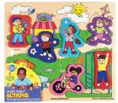](http://rds.yahoo.com/_ylt=A0WTb_uzCBlMr24A5BqJzbkF;_ylu=X3oDMTBqY2pzbGhoBHBvcwMxMQRzZWMDc3IEdnRpZAM-/SIG=1g7hhget0/EXP=1276795443/**http%3a/images.search.yahoo.com/images/view%3fback=http%253A%252F%252Fimages.search.yahoo.com%252Fsearch%252Fimages%253Fp%253Dkids%252Bdoing%252Bpuzzles%2526ei%253Dutf-8%2526fr%253Dsfp%26w=460%26h=403%26imgurl=finewoodentoys.com%252Flibrary%252FSH_chunky_park.jpg%26rurl=http%253A%252F%252Fwww.finewoodentoys.com%252Fpro1171254.html%26size=57k%26name=SH%2bchunky%2bpark%2bj...%26p=kids%2bdoing%2bpuzzles%26oid=84d20d96d365d2e2%26fr2=%26no=11%26tt=98%26sigr=11d1el7ki%26sigi=11dvqd62g%26sigb=12hk8qeei)[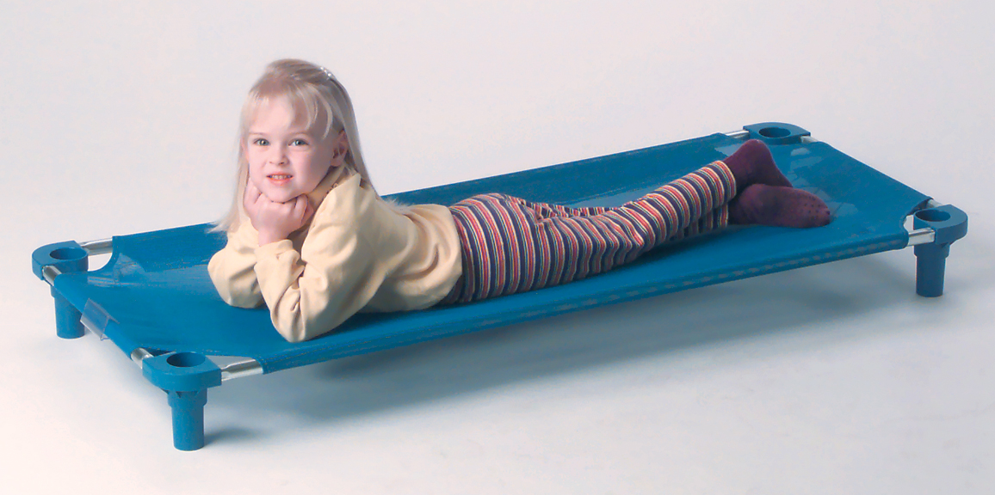](http://www.kidsplayinc.com/product_info.php?cPath=36&products_id=420&osCsid=59aa23db4080dc8608b5d754264d5e9b)